Coastal picocyanobacteria exploit low oxygen habitats

Sylwia Śliwińska-Wilczewska1,2, Mireille Savoie1, Naaman M. Omar1, and Douglas A. Campbell1,✉

1 Department of Biology, Mount Allison University, 53 York St., Sackville, NB, E4L 1C9, Canada  
2 Institute of Oceanography, University of Gdansk, 46 Pilsudskiego St, P81-378, Gdynia, Poland  
3 Department of Geography, University of Victoria, Victoria, BC, V8P 5C2, Canada  
4 Institute of Oceanology, Polish Academy of Sciences, 81-712 Sopot, Poland

✉ Correspondence: [Douglas A. Campbell <[dubhglascambeuil@gmail.com](mailto:dubhglascambeuil@gmail.com)>](mailto:dubhglascambeuil@gmail.com)

# Abstract

xxx

# Introduction

Picocyanobacteria, the most abundant primary producers in marine ecosystems (Flombaum et al. 2013), exhibit remarkable adaptations to thrive in low oxygen environments, such as Oxygen Minimum Zones (OMZs), prevalent at depths in the ocean (Wong et al. 2023). These zones are characterized by exceptionally low dissolved oxygen concentrations, posing challenges for aerobic organisms. However, picocyanobacteria species have evolved diverse strategies to cope with these conditions. Picocyanobacteria, can perform photosynthesis under extremely low light and oxygen levels, utilizing specialized pigments and photosystems to capture and utilize light energy efficiently [XXX citations xxx]. Additionally, some planktonic cyanobacteria species exhibit vertical migration behaviors, moving closer to the surface during nighttime to access oxygen-rich waters and retreating to deeper layers during the day to avoid excessive light exposure (Kromkamp and Walsby 1990). Furthermore, recent studies have highlighted the role of specific genetic adaptations in cyanobacteria populations inhabiting OMZs, enabling them to tolerate and even thrive in oxygen-depleted environments (Ulloa et al. 2012). These adaptations encompass genetic modifications related to energy metabolism, antioxidant defense mechanisms, and cellular structures optimized for oxygen scavenging and storage. Overall, the occurrence and adaptation of picocyanobacteria to low oxygen environments are critical components of marine ecosystems, shaping their productivity and biodiversity in OMZ regions.

# Materials and Methods

## Culture condition and experimental setup

Two xenic cultures of *Synechococcus* sp. (PC-rich CCBA_077 and PE-rich CCBA_127) were obtained from the Culture Collection of Baltic Algae (CCBA; <https://ccba.ug.edu.pl/pages/en/home.php>). *Synechococcus* sp. strains were cultured in Tissue Culture Flasks (VWR International, Cat. No. 10062-872, PA, USA) and transferred biweekly to fresh f/2 media (Guillard 1975) with a salinity at 8 PSU, reflective of their natural habitat. Pre-cultures were maintained in incubators set to full oxygen concentration of 250 µM, temperature of 22℃ with a light/dark cycle of 12 h and Photosynthetically Active Radiation (PAR) of 10 µmol photons m-2s^-1 with illumination from Philips Cool White F14T5/841 Alto, 14 watts, fluorescent bulbs.

Controlled growth experiments were performed using MCMIX-OD PSI Multicultivators (Photon Systems Instruments, Drásov, Czech Republic). Each of 8 round bottom cylindrical glass tubes contained 75 mL of f/2 medium and 5 mL of growing pre-culture. These parameters allowed for exponential growth of the cultures from the beginning of the experiment, with little lag phase after inoculation. The inoculation of culture tubes took place each time in the afternoon, while the sinusoidal photoperiodic cycle commenced the following morning. This cycle ensured that the peak PAR occurred at noon each day.

Cultures grew at 22℃, with peak PAR of 180 µmol photons m−2s−1. To approximate diel cycles, the photoperiods of 12 h were applied in a sinuisoidal shape. Each tube was maintain under an individual combination of 7 spectral bandwidth (405, 445, 470, 535, 620, 660, and 720 nm) and 2 oxygen concentrations (O2; 250 µM and 2.5 µM). A low O2 concentration of ~ 2.5 µM, was achieved by sparging with a gas mixture containing 99.95% N2 and 0.05% CO2. A high O2 concentration of ~ 250 µM was achieved by sparging with lab air (78% N2, 21% O2, 1% Ar and 0.05% CO2). O2 concentration *in situ* was verified using oxygen optodes (PyroScience, Germany) inserted into tubes for real-time measurements. The Pyroscience software corrected O2 concentration based on the salinity of the media (8 PSU). Culture tubes were closed with a silicone inert silicone stopper perforated by an aeration input tube extending to the bottom of the culture tube, and a pressure outlet tube. We used aeration with a total air flow rate of around ~ 140 mL min−1 tube−1 through a 0.2µm sterile microfilter via a G400 gas mixing system (Qubit Systems Inc., Kingston, Ontario, Canada). The pH of tested cultures did not fluctuate fiercely and was about 8 during the experiment. The optical density of the cultures was monitored using the Photobioreactor Control Software (Photon Systems Instruments, Drásov, Czech Republic).

## Chlorophyll-specific exponential growth rates

Picocyanobacterial growth was monitored every 5 minutes by automatically recording OD680, OD720, and ΔOD (ΔOD = OD680 – OD720) for 7 days, independently for each culture tube. The chlorophyll-specific exponential growth rates (µ) were determined by fitting logistic growth curves using a modified Levenberg-Marquardt fitting algorithm (Elzhov et al. 2023) to plots of the chlorophyll *a* proxy of ΔOD vs. elapsed time for each combination of strain, spectral bandwidth, and O2 concentration.

## Whole-cell absorbance spectra, pigment content, and PUR/PAR ratio

Whole-cell absorbance spectra of picocyanobacteria cells were collected using an integrating cavity upgrade spectrophotometer (CLARiTY 17 UV/Vis/NIR, On-Line Instrument Systems, Inc., Bogart, GA, USA) according to the method proposed by Blake and Griff (2012). Each sample and reference observation cavity of the spectrophotometer was filled with 8 mL of f/2 medium. After establishing a baseline absorbance ranging from 375 to 710 nm (f/2 media of salinity 8 PSU), 4 mL of PC-rich_077 or PE-rich_127 culture cell suspension was introduced into the sample cavity, replacing an equal volume of culture medium. Pathlength corrected absorbance per cm was calculated using Jávorfi coefficients (Jávorfi et al. 2006).”

Using an integrating cavity upgrade CLARiTY 17 UV/Vis/NIR spectrophotometer, we conducted estimations of pigment content (µg mL^-1) including chlorophyll *a* (Chl *a*), carotenoids (Car), phycoerythrin (PE), phycocyanin (PC), and allophycocyanin (APC) in PC-rich_077 and PE-rich_127 *Synechococcus* sp. cultures. These estimations were based on established linear correlations between pigment content, determined through extraction methods (Strickland and Parsons 1972; Bennett and Bogorad 1973), and absorbance values of individual pigment peaks (Car; 480 nm, PE; 565 nm, PC; 620 nm, APC; 650 nm, and Chl *a*; 665 nm) obtained from whole-cell absorbance spectra. Additionally, we calculated the ratio of the sum of phycobiliproteins (PE, PC, APC protein) to Chl *a* (µg:µg) for each strain.”

We also estimated the Photosynthetically Usable Radiation (PUR)/Photosynthetically Active Radiation (PAR) ratio which is the fraction of PAR that can be captured by the absorbance of the cells. First, we obtained an emission profile from 370 nm to 750 nm of each coloured LED light of the MCMIX-OD Multicultivator (spectral bandwidth of 405, 445, 470, 535, 620, 660, and 720 nm) using a Jaz spectrometer (Ocean Optics, Inc.,Dunedin, FL, USA) equipped with a fiber optic cable, HH2 FiberOpticJmp (Part number A901073, Malvern Panalytical Ltd, Malvern, UK). Next, each LED spectrum (Em) was normalized to its emission peak maximum (405, 445, 470, 535, 620, 660, and 720 nm). We also normalized the obtained whole-cell absorbance spectra of *Synechococcus* sp. cultures (A) from 400 nm to 700 nm to a reference wavelength of their maximum peak wavelength (440 nm). PUR (µE = µmol photons m−2s−1) was estimated from the formula Eq. (1) according to method proposed by Morel (1978).

$$PUR \left(µE\right)=\frac{∑\left(NormA_{440} × NormEm\right)}{∑\left(NormEm\right)} × PAR \left(µE\right) \left(1\right)$$

where NormA440 is the sum of Absorbance Normalized to 440 nm, NormEm is the sum of Emission spectra Normalized to maximum peak of colur light, and PAR in this case is 180 µmol photons m−2s−1.

## Cumulative diel PAR and PUR

We estimated the value of the cumulative diel PAR (µmol photons m−2d−1) using Eq. (2). Cumulative diel PUR was estimated similarly after estimation of peak PUR from peak PAR.

$$\begin{matrix}Cumulative diel PAR \left(µmol photons m^{−2} d^{−1}\right)= \\ \frac{PAR \left(µE\right)×60 \left(s min^{−1}\right)×60 \left(min h^{−1}\right)×photoperiod \left(h d^{−1}\right)}{2} \left(2\right)\end{matrix}$$

## Picocyanobacteria cell counts

Picocyanobacterial cells (cell mL−1) were counted using an ImageXpress Pico Digital microscope equipped with CMOS camera and LED+ image autofocus (ImageXpress Pico Automated Cell Imaging System, Molecular Devices, LLC., CA, USA). Culture samples were preserved with 4% glutaraldehyde and kept at -80°C until the measurements. Samples (V = 10 µL) were transferred to Tissue Culture (TC)-treated surface, flat bottom black 96-well plates (Corning® Falcon® Microplate, MilliporeSigma, Merck, Darmstadt, Germany) containing 200 µL of f/2 media and centrifuged using a Beckman J-20 centrifuge with a swing bucket JS-4.3 rotor at 4500 rpm (Beckman Coulter, Brea, California, United States). Cells were imaged with the Cy5 channels (Excitation: 630/40 nm; Emission: 695/45 nm; Dichroic: 655 nm) using selectable confocal geometries, which allowed us to distinguish cyanobacterial cells from any co-occurring heterotrophic bacteria, and counted using a 63x objective in fluorescence imaging modes. Quantitative analysis on images acquired from automated microscopy obtained from 96-well microplates was performed using CellReporterXpress Image Acquisition and Analysis Software. The actual cell number was calculated based on the dilution factor and selected area count in each well (Wlodkowic et al. 2022).

## PSII effective absorption cross section of PSII and electron flux

We harvested 2 mL of cultures for photophysiological characterizations repeatedly across the growth trajectories. We used Fast Repetition Rate fluorometry (Kolber et al. 1998) (FRRf, Solisense, USA), with a lab built temperature control jacket (22℃), to apply series of flashlets to drive saturation induction/relaxation trajectories, fit using the onboard Solisense LIFT software (Falkowski and Kolber 1993; Kolber et al. 1998). From the model fits we took the initial fluorescence before induction (*F*O, *F*O′, or *F*S, depending upon the level of actinic light and step in the light response curve); the maximum fluorescence (*F*M or *F*M′) once Photosystem II (PSII) was driven to closure; and the effective absorption cross section for PSII photochemistry (σPSII or σPSII′; nm2 quanta−1) (Tortell and Suggett 2021). We used a double tap protocol (Xu et al. 2017), where FRRf induction/relaxation trajectories were collected during a rapid light curve sequence increasing in steps of 10 s at 0, 20, 40, 80, 160, and 320 µmol photons m−2s−1 PAR, delivered from LED emitters centred at 445, preferentially exciting chlorophyll, or 590 nm, preferentially exciting phycobiliproteins. Flash Power for 445 nm excitation was 60000 µmol photons m−2s−1 PAR, while for 590 nm excitation power was 14000 µmol photons m−2s−1, calibrated using a quantum sensor (LI-250, LI-COR, Inc.). We applied 1 s darkness between sequential light steps, to allow re-opening of PSII. FRRf excitation flashlets were applied at the same wavebands, 445 or 590 nm, as the actinic light steps.

We calculated (Eq. (3)) an uncalibrated fluorescence based estimator for volumetric electron transport, *JV*PSII, (k × e− L−1 s−1) under both 445 and 590 nm excitation bands (Oxborough et al. 2012; Boatman et al. 2019; Tortell and Suggett 2021).

$$JV_{PSII}=\frac{σ_{PSII}′×qP×I×F_{O}}{σ_{PSII}} \left(3\right)$$

where σPSII′ is effective absorption cross section for PSII photochemistry under the relevant actinic PAR step (nm2 quanta−1); qP is an estimate of the fraction of PSII open for photochemistry estimated according to Oxborough and Baker (1997); I is the applied PAR (µmol photons m−2s−1); *F*O is the minimum fluorescence from a given sample and excitation bandwidth (relative fluorescence) and σPSII is the maximum effective absorption cross section for PSII photochemistry from a given sample and excitation bandwidth (nm2 quanta−1). We compared several other algorithms for *JV*PSII (Tortell and Suggett 2021) and found similar results.

We calibrated the *JV*PSII estimator to absolute rates of electron transport (Eq. (4)) using parallel measures of oxygen evolution (µmol O2 L−1 s−1), captured simultaneously with the FRRf measures, below light saturation of electron transport, using a FireSting robust oxygen probe (PyroScience, Germany) inserted in the cuvette for select Rapid Light Curve (RLC) runs. For the blue LED (Ex445nm) excitation we used a calibration slope of 108832, while for orange LED (Ex590nm) excitation we used a calibration slope of 254327

$$JV_{PSII}\left(e^{−} L^{−1} s^{−1}\right)=\frac{Uncalibrated JV_{PSII}\left(e^{−} L^{−1} s^{−1}\right)}{Calibration slope} \left(4\right)$$

At the same time as the FRRf measurements were performed, chlorophyll *a* (Chl *a*) (µg mL−1) and cell count (N mL−1) measurements were also investigated.

Chlorophyll *a* (Chl *a*) (µg mL−1) was measured using Trilogy Laboratory Fluorometer (Turner Designs, Inc., CA, USA) equipped with Chlorophyll In-Vivo Module, previously calibrated using 20 mL ampoules with known Chl *a* concentrations in 3:2 90% acetone:DMSO solution. Quantitative analysis of Chl *a* was obtained after adding 50 µL of culture and 2 mL of a 90% acetone:DMSO solution in a 3:2 ratio.

## Statistical analysis

We used R version 4.3.0 (R Core Team 2023) running under RStudio (Posit team 2022). We performed three-way factorial ANOVA (*aov()* function; R Base package) to determine whether strain, spectral bandwidth, oxygen concentration, and their interactions, significantly influence the chlorophyll-specific exponential growth rate (µ; d−1).

Statistical differences for all analyses were determined at significance level α = 0.05. The manuscript was prepared as a Rmarkdown document (Handel 2020) with figures plotted using ggplot2 (Wickham 2016) and patchwork (Pedersen 2024) packages. All metadata, data and code is available on GitHub (<https://github.com/FundyPhytoPhys/BalticO2>).

# Results

## Chlorophyll-specific exponential growth rate

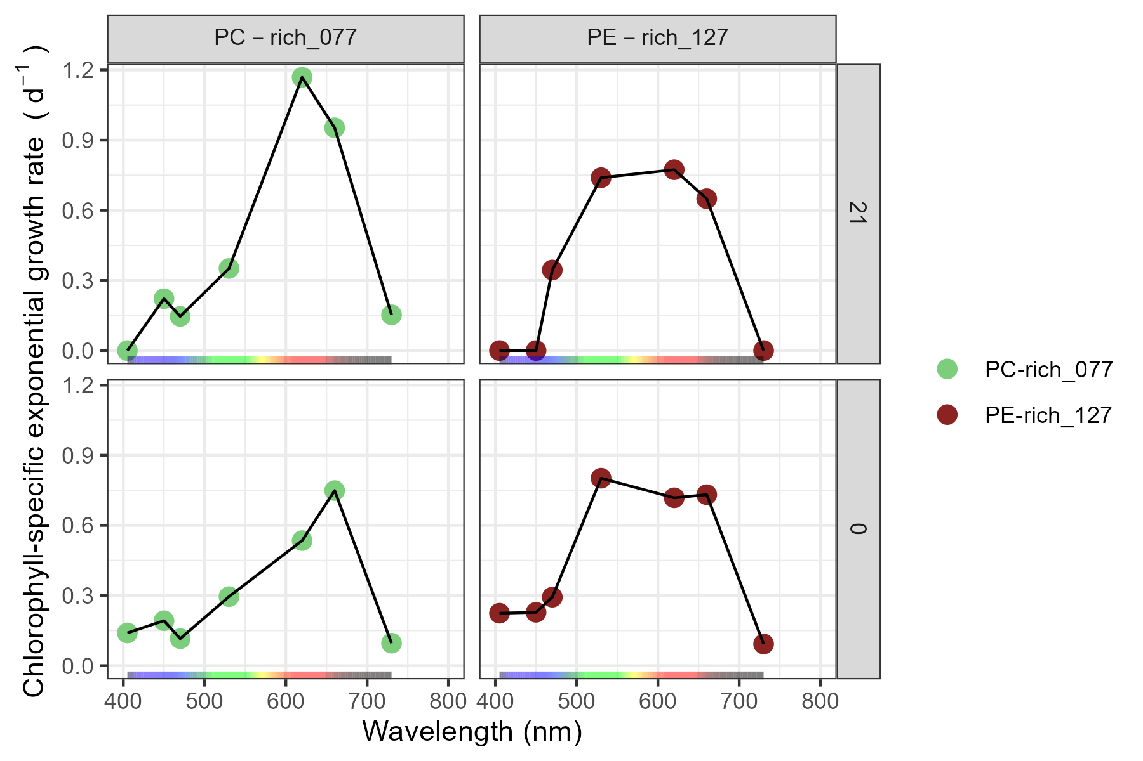

**Fig.** 1: Chlorophyll-specific exponential growth rates (d−1) vs. wavelength (nm). Growth rates (± SE falling within symbols) were estimated from logistic fits of chlorophyll proxy OD680 – OD720 (ΔOD) vs. elapsed time, for PC-rich_077 (light green) and PE-rich_127 (dark red) cultures of *Synechococcus* sp. grown at spectral bandwidth of 405, 445, 470, 535, 620, 660, and 720 nm and O2 concentration of 250 µM and 2.5 µM.

## PUR/PAR ratio vs. spectral bandwidth

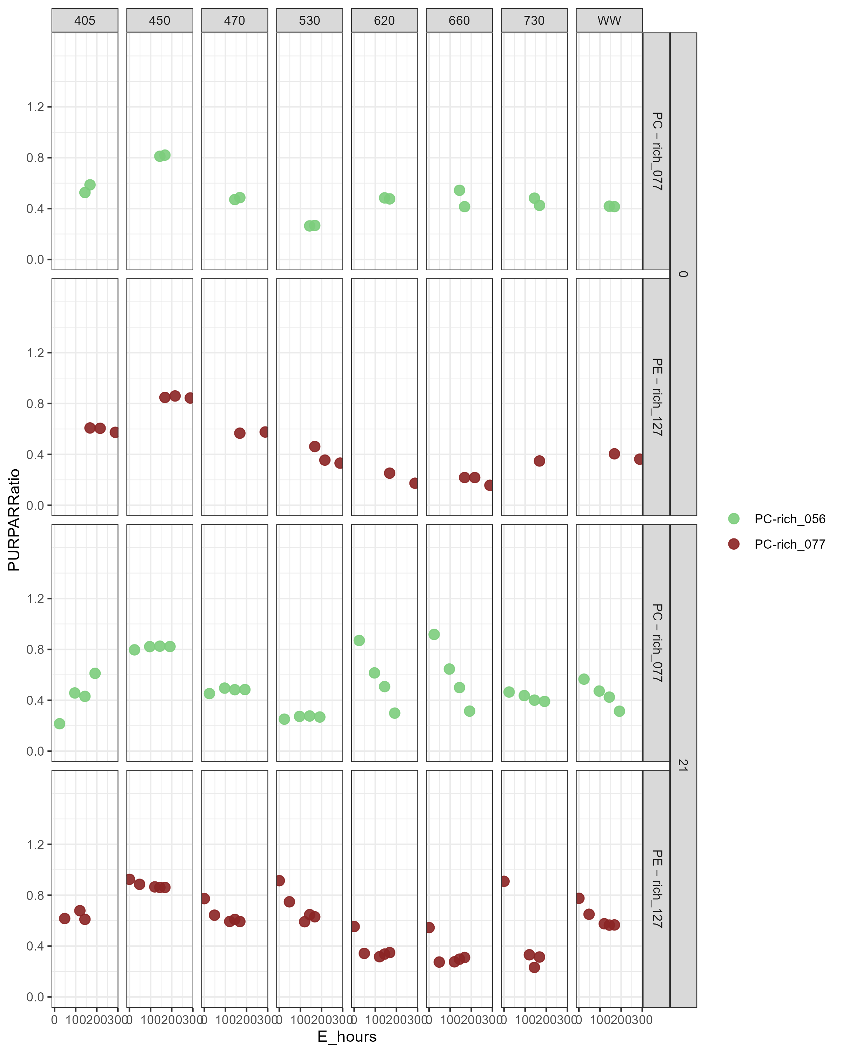

**Fig.** 2: Changes in PUR/PAR ratio vs. wavelength (nm). PUR/PAR ratio was estimated for PC-rich_077 (light green) and PE-rich_127 (dark red) cultures of *Synechococcus* sp. grown at spectral bandwidth of 405, 445, 470, 535, 620, 660, and 720 nm and O2 concentration of 250 µM and 2.5 µM.

# Discussion

# Conclusions

**Additional Supporting Information may be found in the online version of this article.**

**Authors Contribution Statement:** S.S-W. designed the study with input from D.A.C. M.S. ensured the proper operation of the photobioreactors. N.M.O. solved technical problems related to computer operation and software. S.S-W., M.S., N.M.O., D.A.C. contributed to R coding and data analysis. S.S-W. conducted the experiments, created plots and wrote the manuscript, with support from D.A.C. All authors contributed to the discussion of the results, supported manuscript preparation, and approved the final submitted manuscript.

# Data availability statement

Data supporting this study is available on: <https://github.com/FundyPhytoPhys/BalticO2> (public GitHub Repository) and <https://docs.google.com/spreadsheets/d/1ZXpwR7Gfto-uRzVdXzMpQF4frbrvMLH_IyLqonFZRSw/edit#gid=0> (URL for MetaDataCatalog).

Code to perform data processing and analyses is available at <https://github.com/FundyPhytoPhys/BalticO2>.

## Acknowledgements

We thank Miranda Corkum who maintained cultures and trained personnel in culture handling; Laurel Genge, and Carlie Barnhill (Mount Allison students) who assisted with R code. This work was supported by Canada Research Chair in Phytoplankton Ecophysiology (D.A.C) and Latitude & Light; NSERC of Canada Discovery Grant (D.A.C).

## Conflict of Interest

None declared.

# References

Bennett, A., and Bogorad, L. 1973. Complementary Chromatic Adaptation in a filamentous blue-green alga. Journal of Cell Biology **58**(2): 419–435. doi:[10.1083/jcb.58.2.419](https://doi.org/10.1083/jcb.58.2.419).

Blake, R., and Griff, M. 2012. In situ spectroscopy on intact *Leptospirillum* *Ferrooxidans* reveals that reduced cytochrome 579 is an obligatory intermediate in the aerobic iron respiratory chain. Frontiers in Microbiology **3**. [accessed 13 June 2023].

Boatman, T.G., Geider, R.J., and Oxborough, K. 2019. Improving the accuracy of Single Turnover Active Fluorometry (STAF) for the estimation of Phytoplankton Primary Productivity (PhytoPP). Frontiers in Marine Science **6**. Frontiers. doi:[10.3389/fmars.2019.00319](https://doi.org/10.3389/fmars.2019.00319).

Elzhov, T.V., Mullen, K.M., Spiess, A.-N., and Bolker, B. 2023, September. Minpack.lm: R Interface to the Levenberg-Marquardt Nonlinear Least-Squares Algorithm Found in MINPACK, Plus Support for Bounds. [accessed 15 March 2024].

Falkowski, P., and Kolber, Z. 1993. Estimation of phytoplankton photosynthesis by active fluorescence. ICES Marine Science Symposium **197**: 92–103.

Flombaum, P., Gallegos, J.L., Gordillo, R.A., Rincón, J., Zabala, L.L., Jiao, N., Karl, D.M., Li, W.K.W., Lomas, M.W., Veneziano, D., Vera, C.S., Vrugt, J.A., and Martiny, A.C. 2013. Present and future global distributions of the marine Cyanobacteria *Prochlorococcus* and *Synechococcus*. Proceedings of the National Academy of Sciences **110**(24): 9824–9829. Proceedings of the National Academy of Sciences. doi:[10.1073/pnas.1307701110](https://doi.org/10.1073/pnas.1307701110).

Guillard, R.R.L. 1975. Culture of phytoplankton for feeding marine invertebrates. *In* Culture of Marine Invertebrate Animals: Proceedings — 1st Conference on Culture of Marine Invertebrate Animals Greenport. *Edited by* W.L. Smith and M.H. Chanley. Springer US, Boston, MA. pp. 29–60. doi:[10.1007/978-1-4615-8714-9_3](https://doi.org/10.1007/978-1-4615-8714-9_3).

Handel, A. 2020, October. Andreas Handel - Custom Word formatting using R Markdown. https://www.andreashandel.com/posts/2020-10-07-custom-word-format/. [accessed 13 June 2023].

Jávorfi, T., Erostyák, J., Gál, J., Buzády, A., Menczel, L., Garab, G., and Razi Naqvi, K. 2006. Quantitative spectrophotometry using integrating cavities. Journal of Photochemistry and Photobiology B: Biology **82**(2): 127–131. doi:[10.1016/j.jphotobiol.2005.10.002](https://doi.org/10.1016/j.jphotobiol.2005.10.002).

Kolber, Z.S., Prášil, O., and Falkowski, P.G. 1998. Measurements of variable chlorophyll fluorescence using fast repetition rate techniques: Defining methodology and experimental protocols. Biochimica et Biophysica Acta (BBA) - Bioenergetics **1367**(1): 88–106. doi:[10.1016/S0005-2728(98)00135-2](https://doi.org/10.1016/S0005-2728(98)00135-2).

Kromkamp, J., and Walsby, A.E. 1990. A computer model of buoyancy and vertical migration in cyanobacteria. Journal of Plankton Research **12**(1): 161–183. doi:[10.1093/plankt/12.1.161](https://doi.org/10.1093/plankt/12.1.161).

Morel, A. 1978. Available, usable, and stored radiant energy in relation to marine photosynthesis. Deep Sea Research **25**(8): 673–688. doi:[10.1016/0146-6291(78)90623-9](https://doi.org/10.1016/0146-6291(78)90623-9).

Oxborough, K., and Baker, N.R. 1997. Resolving chlorophyll *a* fluorescence images of photosynthetic efficiency into photochemical and non-photochemical components – calculation of qP and Fv-/Fm-; without measuring Fo-; Photosynthesis Research **54**(2): 135–142. doi:[10.1023/A:1005936823310](https://doi.org/10.1023/A:1005936823310).

Oxborough, K., Moore, C.M., Suggett, D.J., Lawson, T., Chan, H.G., and Geider, R.J. 2012. Direct estimation of functional PSII reaction center concentration and PSII electron flux on a volume basis: A new approach to the analysis of Fast Repetition Rate fluorometry (FRRf) data. Limnology and Oceanography: Methods **10**(3): 142–154. doi:[10.4319/lom.2012.10.142](https://doi.org/10.4319/lom.2012.10.142).

Pedersen, T.L. 2024, January. Patchwork: The Composer of Plots. [accessed 20 April 2024].

Posit team. 2022. RStudio: Integrated development environment for r. Posit Software, PBC, Boston, MA. Available from <http://www.posit.co/>.

R Core Team. 2023. R: A language and environment for statistical computing. R Foundation for Statistical Computing, Vienna, Austria. Available from <https://www.R-project.org/>.

Strickland, J.D., and Parsons, T.R. 1972. Practical Hand Book of Seawater Analysis. Fisheries Research Board of Canada **167 (2nd edition)**: 1–311. doi:<DOI: http://dx.doi.org/10.25607/OBP-1791>.

Tortell, P., and Suggett, D.J. 2021. A user guide for the application of Single Turnover active chlorophyll fluorescence for phytoplankton productivity measurements. Version 1. Report, Scientific Committee on Oceanic Research (SCOR) Working Group 156. doi:[10.25607/OBP-1084](https://doi.org/10.25607/OBP-1084).

Ulloa, O., Canfield, D.E., DeLong, E.F., Letelier, R.M., and Stewart, F.J. 2012. Microbial oceanography of anoxic oxygen minimum zones. Proceedings of the National Academy of Sciences **109**(40): 15996–16003. Proceedings of the National Academy of Sciences. doi:[10.1073/pnas.1205009109](https://doi.org/10.1073/pnas.1205009109).

Wickham, H. 2016. Data Analysis. *In* Ggplot2: Elegant Graphics for Data Analysis. *Edited by* H. Wickham. Springer International Publishing, Cham. pp. 189–201. doi:[10.1007/978-3-319-24277-4_9](https://doi.org/10.1007/978-3-319-24277-4_9).

Wlodkowic, D., Czerw, A., Karakiewicz, B., and Deptała, A. 2022. Recent progress in cytometric technologies and their applications in ecotoxicology and environmental risk assessment. Cytometry Part A **101**(3): 203–219. doi:[10.1002/cyto.a.24508](https://doi.org/10.1002/cyto.a.24508).

Wong, J.C.Y., Raven, J.A., Aldunate, M., Silva, S., Gaitán-Espitia, J.D., Vargas, C.A., Ulloa, O., and von Dassow, P. 2023. Do phytoplankton require oxygen to survive? A hypothesis and model synthesis from oxygen minimum zones. Limnology and Oceanography **68**(7): 1417–1437. doi:[10.1002/lno.12367](https://doi.org/10.1002/lno.12367).

Xu, K., Grant-Burt, J.L., Donaher, N., and Campbell, D.A. 2017. Connectivity among Photosystem II centers in phytoplankters: Patterns and responses. Biochimica et Biophysica Acta (BBA) - Bioenergetics **1858**(6): 459–474. doi:[10.1016/j.bbabio.2017.03.003](https://doi.org/10.1016/j.bbabio.2017.03.003).